EHB222E-Introductions to Electornics-CRN:10821-Homework

Yunus Güngör No:150150701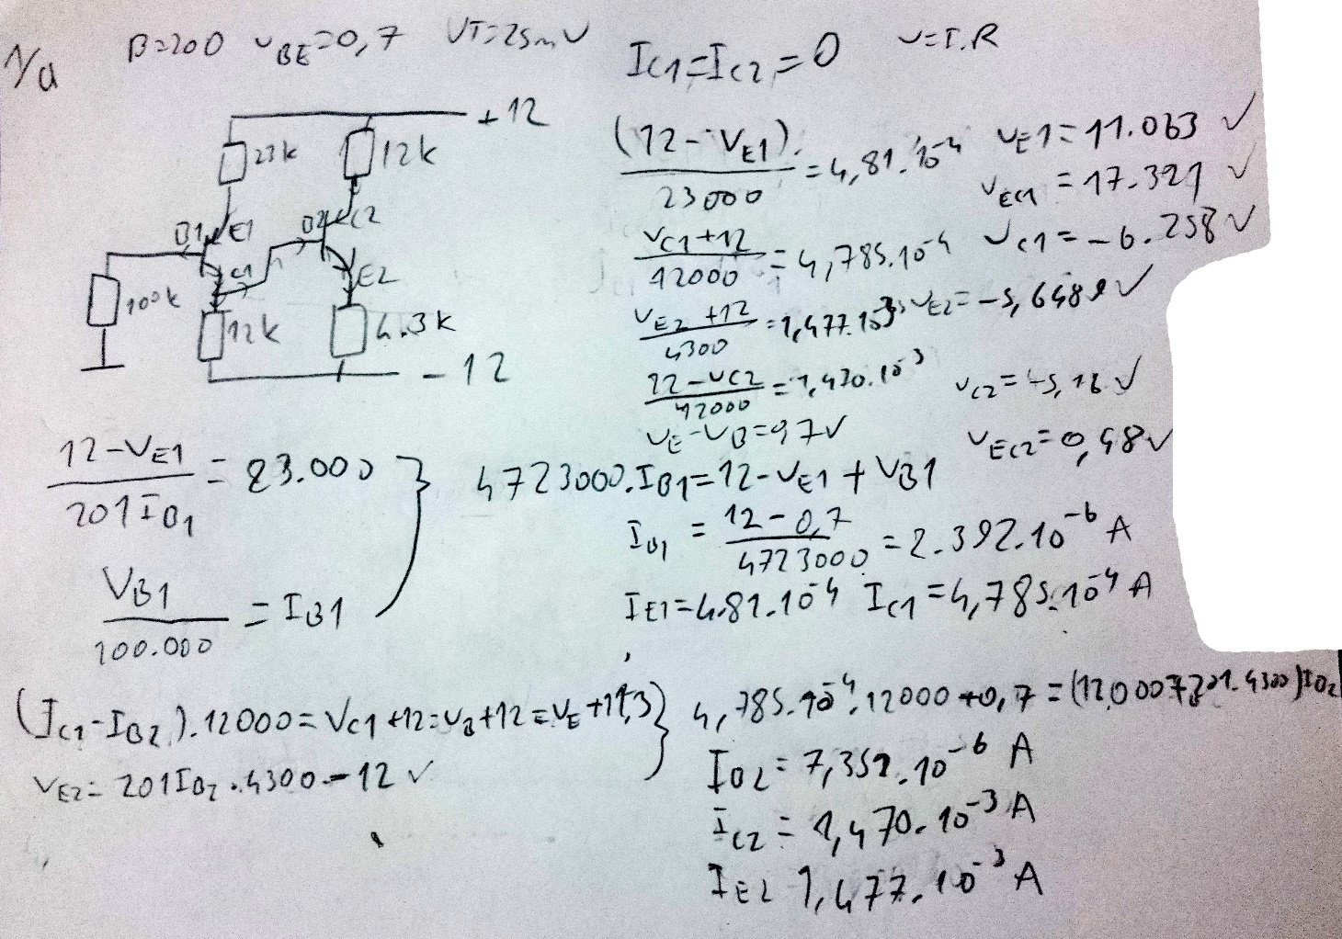

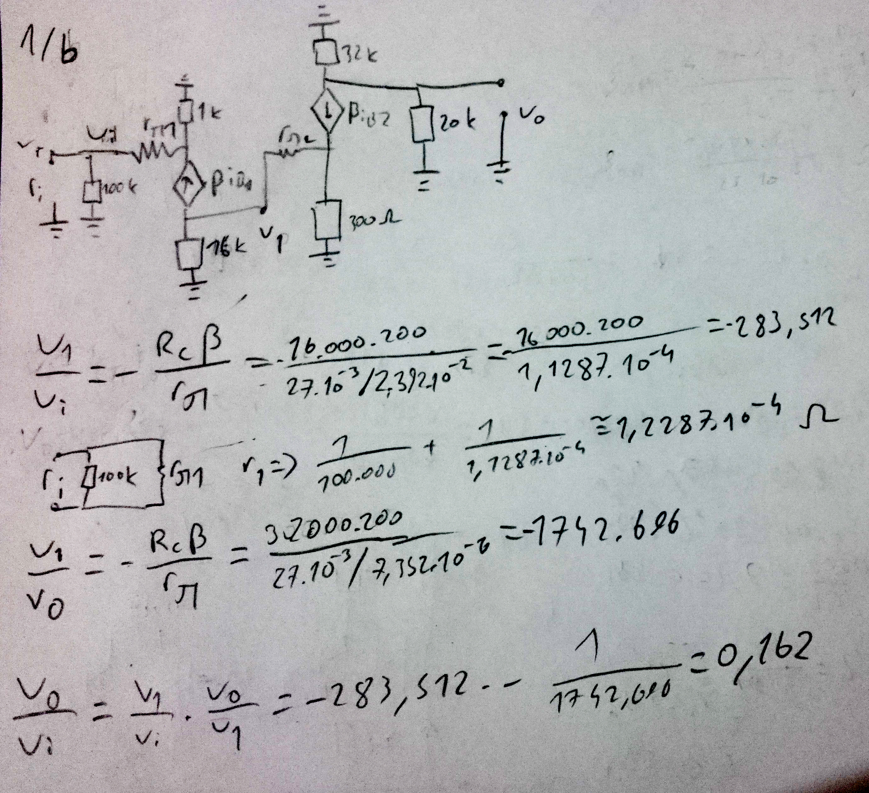

2) 